**2016 Temporary Employment**

**OUTREACH NOTICE**

***George Washington and Jefferson National Forests***

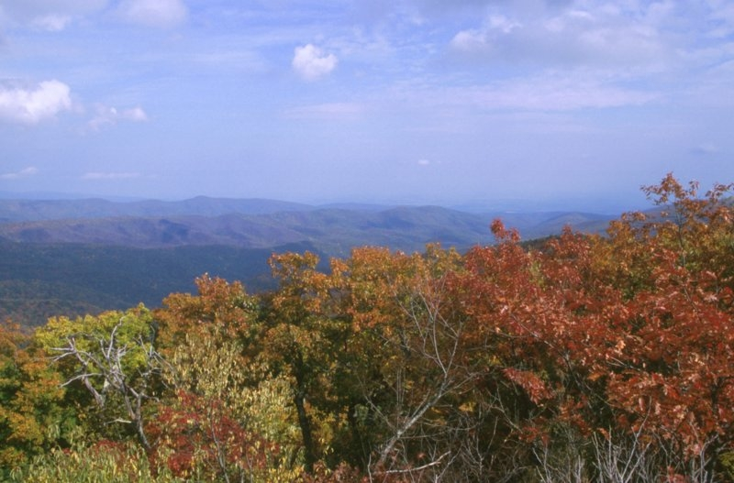

The George Washington and Jefferson National Forests will be advertising and filling a number of temporary positions for the 2016 summer season. The employment period for most positions is anticipated to be early April through late August/early September 2016, depending on Ranger District location. This Outreach is being circulated to inform prospective applicants of this upcoming opportunity.

The George Washington and Jefferson National Forests stretch along the ruggedly beautiful Appalachian Mountains, extending from one end of Virginia to the other and even crossing into parts of West Virginia and Kentucky.  The two national forests contain nearly 1.8 million acres; one of the largest blocks of public land in the eastern United States. The forests headquarters is the Forest Supervisor’s Office in Roanoke, Virginia with eight Ranger District offices.

To express your interest and receive notice of the Vacancy Announcements, please contact or return the attached form to a Ranger District contact by **January 22, 2016**.

**Positions**

Positions require working in all types of weather, and the employee must be capable of hiking long distances in remote areas or operate power equipment for extended periods of time, and perform physical labor, including bending, lifting, and carrying up to 40 pounds or more. Some positions require wearing a Forest Service uniform daily (provided). Weekend and holiday work is required for some positions. A valid driver’s license and DMV driving record are required. Pay rates for positons depend on the grade.

|  |  |  |  |  |  |  |  |  |  |  |  |  |
| --- | --- | --- | --- | --- | --- | --- | --- | --- | --- | --- | --- | --- |
|  |  | **Forestry Technician -Recreation** | | | **Forestry Technician Trails** | **Forestry Aid (Fire Suppression)** | **Information Assistant** | | **Forestry Tech Silviculture** | | **Biological Science** | |
| **District** | **Location** | **GS-3** | **GS-4** | **GS-5** | **GS-4** | **GS-3** | **GS-3** | **GS-4** | **GS-4** | **GS-5** | **GS-3** | **GS-4** |
| Clinch RD | Norton | x |  |  |  | x |  |  |  |  |  |  |
| Eastern Divide RD | Blacksburg |  | x |  |  |  | x |  |  | x |  |  |
| Glenwood & Pedlar RD | Natural Bridge Station | x |  |  | x |  |  |  |  |  |  |  |
|  | Lyndhurst | x |  |  |  |  |  |  |  |  |  |  |
| James River/Warm Springs RD | Covington |  | x | x |  |  |  | x |  |  |  |  |
|  | Hot Springs |  | x | x |  |  |  |  |  |  |  |  |
| Lee RD | Edinburg |  | x |  | x |  |  |  | x |  |  |  |
|  | Lost City WV |  | x |  |  |  |  |  |  |  |  |  |
| North River RD | Harrisonburg | x |  |  |  |  |  |  |  |  | x | x |

**Major Duties of Positions (Based on 2015 rates; 2016 may change)**

**Forestry Technician – Recreation**

|  |  |
| --- | --- |
| Series and Grade | Hourly Pay |
| GS-0462-03 | $12.19 |
| GS-0462-04 | $13.68 |
| GS-0462-05 | $15.31 |

These recreation positions perform maintenance and improvement work in recreation areas on the District. Recreation work could include garbage and litter pick-up, toilet cleaning, grass mowing and weed-eating, and minor construction and repair of recreation facilities. Some GS-4 and GS-5 positions will be crew leaders.

**Forestry Technician – Fire Suppression**

|  |  |
| --- | --- |
| Series and Grade | Hourly Pay |
| GS-0462-03 | $12.19 |

The position is located on a fire crew as a crewmember within the fire management organization.

The purpose of the position is wildland fire suppression/management/control, as a firefighter on an engine, hotshot, helitack or hand crew. Other wildland fire related duties might involve fire prevention, patrol, detection, or prescribed burning. The incumbent will also be involved with the maintenance and repair of firefighting tools equipment and facilities, and will receive firefighting training. If this position description is used to fill a vacancy on a helitack module, the selected applicant must possess a minimum of one season (90-days) of experience as a NWCG Wildland Firefighter Type 2 (FFT1) as per Forest Service policy (FSFAQG Chapter 4).

**Forestry Technician – Trails**

|  |  |
| --- | --- |
| Series and Grade | Hourly Pay |
| GS-0462-04 | $13.68 |

These trail positions perform maintenance and improvement work on non-motorized trails. Trail work may involve clearing and brushing trail corridors, installing signage, and constructing trails, drainage structures and bridges. Some GS-4 positions will be crew leaders.

**Forestry Technician – Silviculture**

|  |  |
| --- | --- |
| Series and Grade | Hourly Pay |
| GS-0462-04 | $13.68 |
| GS-0462-04 | $15.31 |

This position will primarily work on timber stand improvement activities, including treatment of non-native invasive species, crop tree release, reforestation, data collection to support silvicultural prescriptions and NEPA.

**Biological Science Aid/Technician**

|  |  |
| --- | --- |
| Series and Grade | Hourly Pay |
| GS-0404-03 | $12.19 |
| GS-0404-04 | $13.68 |

This Biological Aid/Technician position will work on wildlife and fisheries habitat improvement projects and non-native invasive species control.

**Information Assistant**

|  |  |
| --- | --- |
| Series and Grade | Hourly Pay |
| GS-0303-03 | $12.19 |
| GS-0303-04 | $13.68 |

This position is located on a Forest Service unit to provide information services such as greeting visitors, answering telephones, responding to routine inquiries from a variety of customers, and providing overall support to the administrative staff on the unit.

***For more information about the Forest visit:*** [***http://www.fs.usda.gov/gwj***](http://www.fs.usda.gov/gwj)

***The Districts:***

**The Clinch Ranger District** is the most southern district located on the Jefferson National Forest and manages the counties of Dickenson, Letcher (KY), Lee, Pike (KY), Scott, and Wise. Employee will be involved predominantly in Recreation Management activities. **The duty station is Norton, VA.**

**_______________________________________________________________**

**The Eastern Divide Ranger District** is on the Jefferson National Forest and runs from Botetourt county on the north end to Tazewell county on the south end, all west of I-81, including the counties of Bland, Botetourt, Craig, Giles, Monroe (WV), Montgomery, Pulaski, Roanoke, Smyth, Tazewell, and Wythe. **The duty station is Blacksburg, VA.**

**_______________________________________________________________**

**The Glenwood & Pedlar Ranger District** is headquartered in Natural Bridge Station, VA and is located on both the George Washington and Jefferson National Forests and manages the counties of Amherst, Augusta, Bedford, Botetourt, Nelson, and Rockbridge.

The combined Districts are about 224,000 acres in size. The *Blue Ridge Parkway* (administered by the National Park Service) extends through the length of the Districts, as does approximately 110 miles of the *Appalachian National Scenic Trail*.  There are five *wildernesses* on the Districts:  Saint Mary’s, The Priest, Three Ridges, James River Face and Thunder Ridge.  In addition to the Appalachian Trail, there are approximately 109 miles of other recreation trails on the Districts.  In addition, there is a 65 mile designated Horse Trail and an 18 mile ATV Trail system.  The Districts have an extensive recreation program with two major developed recreation areas (Sherando Lake Recreation Area and Cave Mountain Lake Recreation Area), as well as several smaller campgrounds and other recreation sites. **The duty stations are Natural Bridge Station and Lyndhurst, VA.** Limited housing is available for seasonal positions on a first come, first serve basis on the Glenwood & Pedlar Ranger District.

**_______________________________________________________________**

**The Warm Springs and James River Ranger Districts** are located in the Alleghany Mountains of western Virginia within the counties of Alleghany, Bath and Highland. Lake Moomaw, one of the largest lakes in VA, is the centerpiece of recreation on both districts. Two congressionally designated wilderness areas are located on the James River Ranger District. Several developed and dispersed recreation sites offer a multitude of opportunities for recreation and enjoying nature. Over 300 miles of multi-use trails course through the mountains and valleys offering day hikes or backpacking experiences for trail enthusiasts. **The duty stations are Covington and Hot Springs, VA.**

**The Lee Ranger District** is the most northern district and is located on the George Washington National Forest managing the counties of Frederick, Hampshire (WV), Hardy (WV), Page, Rockingham, Shenandoah, and Warren. The closest District to the Washington, D.C. metro area, the Lee District features very busy trails and recreation areas. The Lee has over 300 miles of multiple use trails, including an OHV motorized trail system. The Lee District is also rich in history, from local iron and tanning industries and numerous Civil war sites. **The duty stations are Edinburg, VA and Lost City, WV.**

**________________________________________________________________**

**The North River Ranger District** covers nearly 395,000 acres in six counties in two states including: Rockingham, Augusta, Rockbridge, Bath, Highland and Pendleton (WV) counties.  The District is mountainous, with elevations ranging from 1,100 to 4,100 feet.  There are ten lakes stocked for fishing, as well as several stocked and native trout streams.  Developed recreation facilities include five campgrounds, six picnic areas, two swimming beaches, and two shooting ranges.  An extensive system of trails provides opportunities for hiking, horseback riding, and mountain biking.   The District office is located in Harrisonburg, Virginia, just outside the community of Bridgewater. Harrisonburg, a full service community with a population of approximately 41,000, is situated in the middle of the beautiful and historic Shenandoah Valley.  Richmond, Roanoke, and Washington D.C. can all be reached within a two-hour drive.  The Shenandoah National Park and the Blue Ridge Parkway are both within a 30-minute drive. **The duty station is Harrisonburg, VA.**

**_______________________________________________________________**

For further information concerning positions offered at each district, please contact the individual district office.

|  |  |  |  |  |
| --- | --- | --- | --- | --- |
| **District** | **Location** | **Contact** | **Phone** | **email** |
|  |  |  |  |  |
| Clinch RD | Norton | David Skinner (Rec) Or Terry Adams (Fire) | 276-679-8370 | [dlskinner@fs.fed.us](mailto:dlskinner@fs.fed.us)  terryadams@fs.fed.us |
| Eastern Divide RD | Blacksburg | Sheryl Mills (Rec), Mark Miller (Silv) or Heather Harkley (Info Asst) | 540-552-4641 | [sherylmills@fs.fed.us](mailto:sherylmills@fs.fed.us)  [markmiller@fs.fed.us](mailto:markmiller@fs.fed.us)  [hharkley@fs.fed.us](mailto:hharkley@fs.fed.us) |
| Glenwood & Pedlar RD | Natural Bridge Station & Lyndhurst | Tina Southall | 540-291-2188 | [tsouthall@fs.fed.us](mailto:tsouthall@fs.fed.us) |
| James River/Warm Springs RD | Covington & Hot Springs | Emily Ellis (Rec) or Kathy Spurgeon (Info Asst) | 540-839-2521 | [emilyellis@fs.fed.us](mailto:emilyellis@fs.fed.us)  [kspurgeon@fs.fed.us](mailto:kspurgeon@fs.fed.us) |
| Lee RD | Edinburg VA & Lost River WV | Trent Milam (rec)  Kevin Kyle (silv) | 540-984-4101 | [trentfmilam@fs.fed.us](mailto:trentfmilam@fs.fed.us)  [khkyle@fs.fed.us](mailto:khkyle@fs.fed.us) |
| North River RD | Harrisonburg | Donna Burns | 540-432-0187 | [dfburns@fs.fed.us](mailto:dfburns@fs.fed.us) |