Studio Art
Department of Art
& Art History
Melchers Hall

Department Website

Department Chair
Jon McMillan
214 Melchers Hall
jmcmilla@umw.edu
540-654-1936

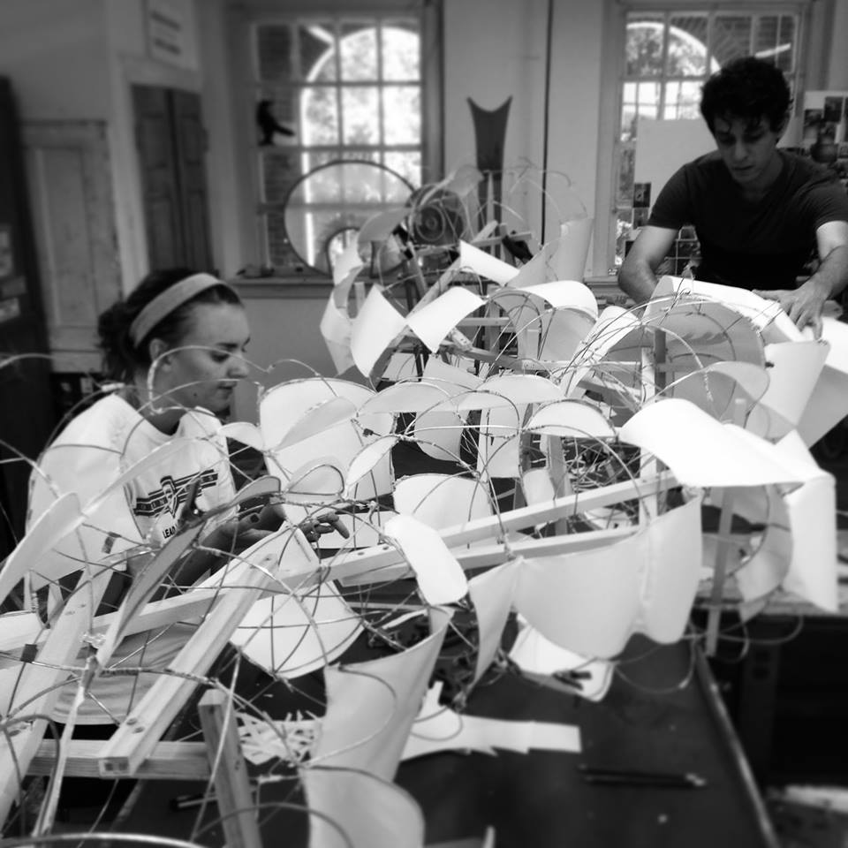
“The studio art program at UMW is located halfway between Washington D.C. and Richmond, where art is in abundance and the opportunities to see the real deal are vast and varied. Our majors are doing wonderful things out in the professional world and we couldn’t be prouder of their achievements. Please visit our department website at: http://cas.umw.edu/art/ and consider joining the UMW Student Art Association Facebook page to find out about the daily happenings in our department. Stop by Melchers Hall to see our studios and check out our creative community in action.” Jon McMillan
New students considering a major in studio art should try to register for ARTS 104 and ARTS 105 as early as possible.
Below are some examples of first semester schedules for a studio art major. There are many variations of a first semester schedule; the examples are just meant to help you see that there are many ways to reach the same goals.
Example 1:
Course (credits) | Requirement(s) Met
- ARTS 105: Design Principles (3)  - ARTH 118: History of Asian Art (3)  - MATH 110: Finite Mathematics (3)  - ANTH 101: Intro Cultural/Social Anthropology (3)  - FSEM 100H7: Environmental Art (3) | Major, AL  Major, DGP  QREA  HUM FSEM
Example 2:
Course (credits) | Requirement(s) Met
- ARTS 105: Design Principles (3)  - FSEM 100J2: Creating Art and Ideas (3)  - EESC 111: Our Dynamic Earth with Lab (4)  - ARTH 114A: History of Western Art I (3) | Major, AL  FSEM  NSL  Major, HUM
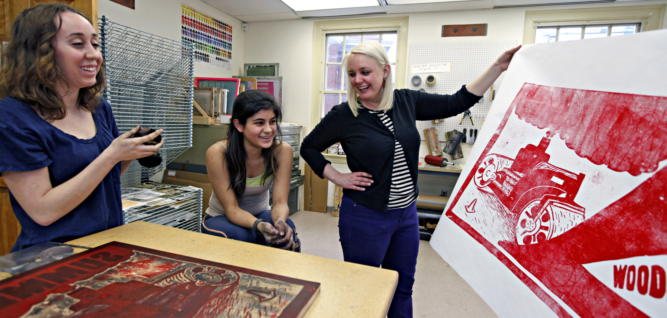
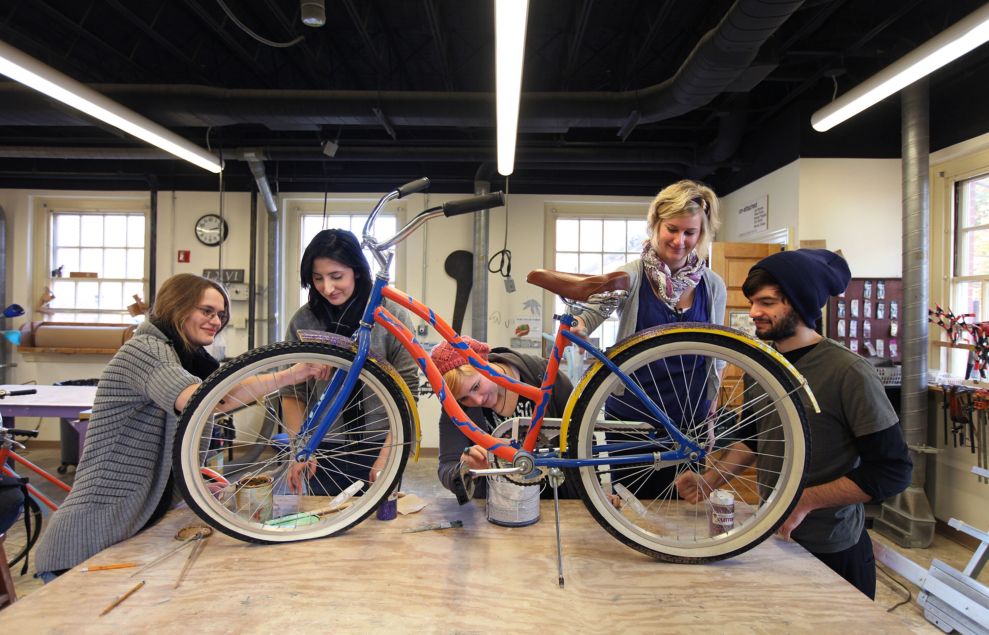

Example 3: Athletes for varsity sports must register for the 400-level course of the sport. Practice times for varsity sports can vary, but generally speaking, athletes should allow for enough time to get to and from practice on weekdays from 3 - 6 p.m. Please check with the individual coach for your sport to verify specific practice times each semester.
Course (credits) | Requirement(s) Met
- ARTS 105: Design Principles (3)  - SPAN 101**: Beginning Spanish (3)  - FSEM 100J2: Creating Art and Ideas (3)  - PHYS 101: General Physics with Lab (4)  - PHYD 406: Intercollegiate Cross Country - Men (1) | Major, AL  LANG  FSEM  NSL  Elective
*Please note that not all sections of a course may have the Speaking Intensive (SI) or Writing Intensive (WI) attributes. These designations for a course are dependent on instructor and semester, and are listed in the Banner description for the semester in which you are registering.
**This particular course is in a discipline that allows students with demonstrated competence upon admission to UMW (such as AP/IB credit, dual enrollment, etc.) to begin courses at a higher level. Talk to your Student Success Coordinator if you believe you should start at a higher level.

