Art History
Art history is one of the best means we have to connect with people from other times, places, and cultures. Julia DeLancey, Art History
Studying the history of beautiful things is what we do. It’s an inspiring journey. Joe Dreiss, Art History
Delving into the details of art brings us so much pleasure, and that’s why we study the history of art. Suzie Kim, Art History
The history of art puts us in touch with people around the globe and across time…it’s an amazing conversation! Marjorie Och, Art History
Department of Art
& Art History
Melchers Hall

Department Website

Department Chair
Jon McMillan
214 Melchers Hall
jmcmilla@umw.edu
540-654-1936

We recommend that students considering a major in art history take either ARTH 114A, 115A, or 118 in their first year. Below please find some examples of first semester schedules for an art history major. There are many variations of a first semester schedule; the examples are just meant to help you see that there are many ways to reach the same goals.
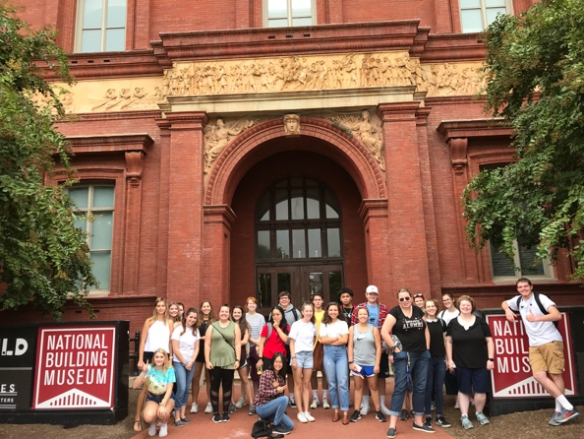
Example 1:
Course (credits) | Requirement(s) Met
- ARTH 114A - History of Western Art I (3)  - MUTH – Music Theory (3)  - BIOL 121 - Biology Concepts I with Lab (4)  - ITAL 101** - Beginning Italian (3)  - FSEM 100Q2 – The Beauty Difference Gives Us (3) | Major, AL  QREA  NSL  LANG  FSEM
Example 2:
Course (credits) | Requirement(s) Met
- ARTH 115A - History of Western Art II (3)  - COMM 205 - Public Speaking (3)  - CHEM 105A - Chemistry & Society I with Lab (4)  - FSEM 100N7 – Architecture Now (3)  - ANTH 101 – Intro to Cultural/Social Anthropology (3) | Major, AL  Elective, SI*  NSL  FSEM  HUM
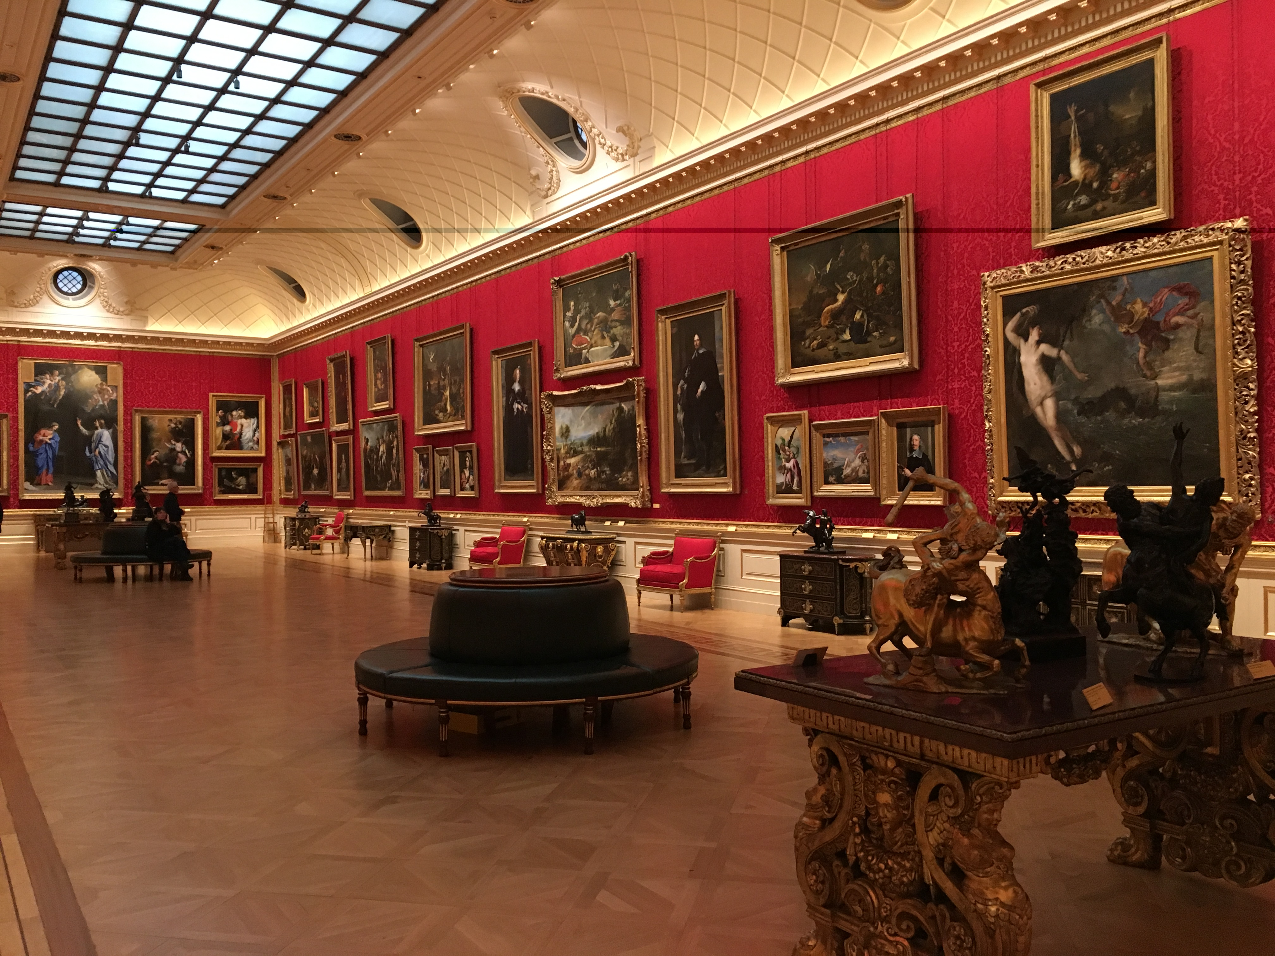
Example 3: Athletes for varsity sports must register for the 400-level course of the sport. Practice times for varsity sports can vary, but generally speaking, athletes should allow for enough time to get to and from practice on weekdays from 3 - 6 p.m. Please check with the individual coach for your sport to verify specific practice times each semester.
Course (credits) | Requirement(s) Met
- ARTH 118 - History of Asian Art I (3)  - GEOG 102 - Human Geography (3)  - GERM 101** - Beginning German (3)  - FSEM 100J2 - Creating Art and Ideas  - PHYD 404 - Intercollegiate Basketball - Women (1) | Major, AL, DGP  HUM  LANG  FSEM  Elective
*Please note that not all sections of a course may have the Speaking Intensive (SI) or Writing Intensive (WI) attributes. These designations for a course are dependent on instructor and semester, and are listed in the Banner description for the semester in which you are registering.
**This particular course is in a discipline that allows students with demonstrated competence upon admission to UMW (such as AP/IB credit, dual enrollment, etc.) to begin courses at a higher level. Talk to your Student Success Coordinator if you believe you should start at a higher level.

